DSA Leet code Programs

226. Invert Binary Tree
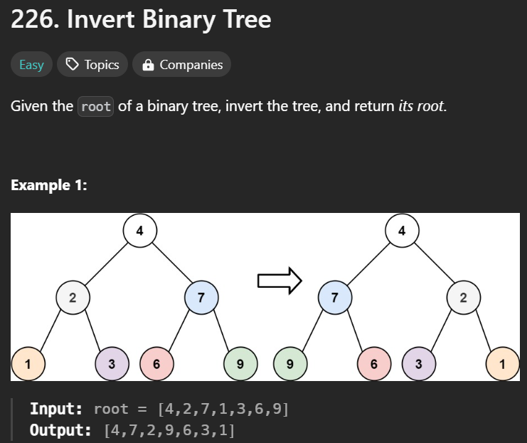
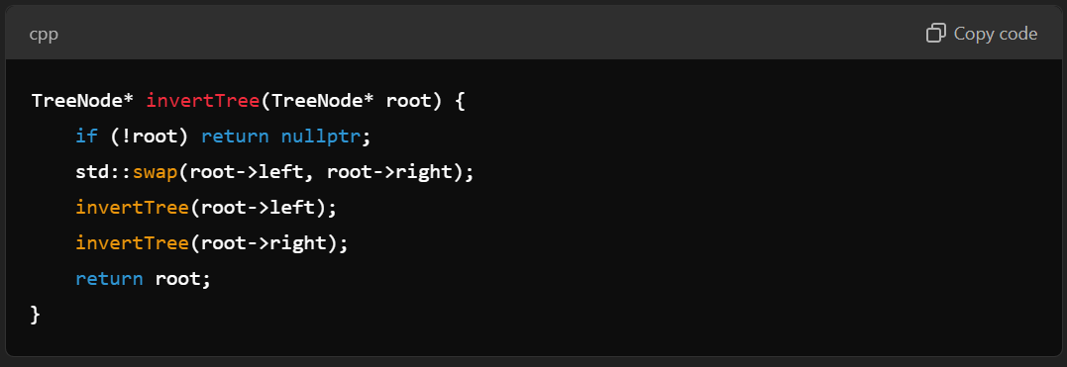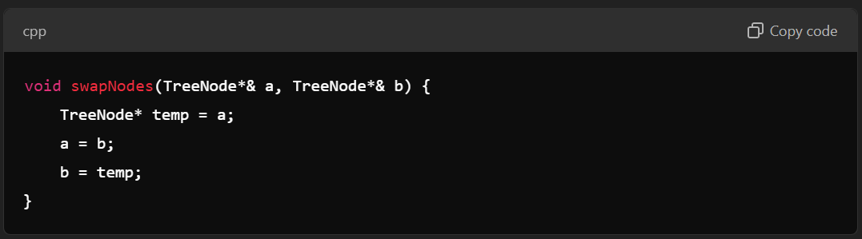
2. Add Two Numbers
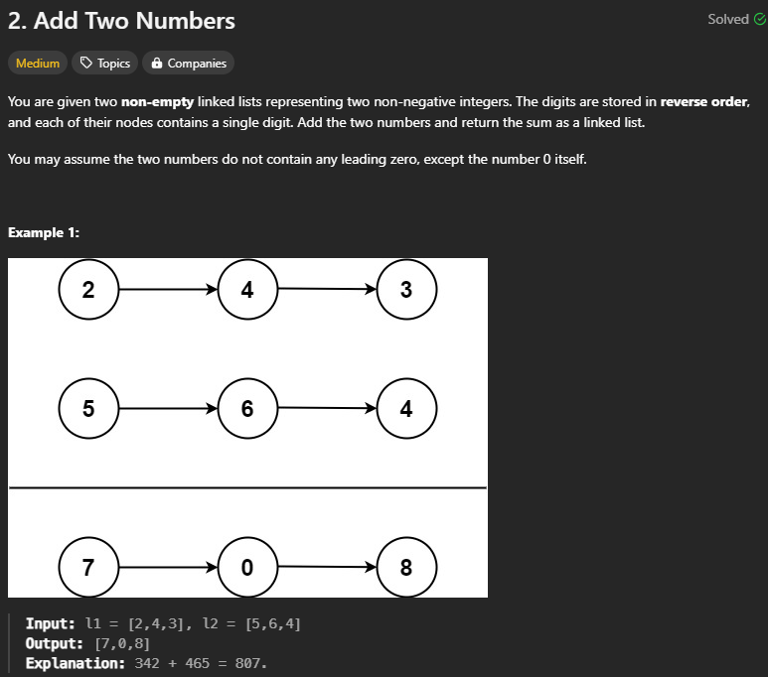
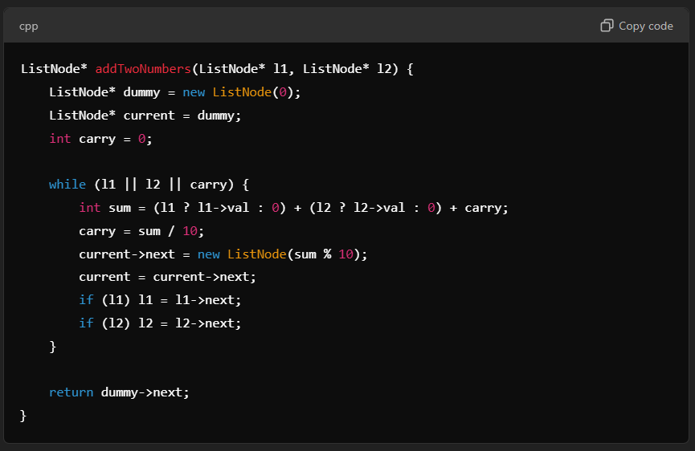
In-order Successor/Predecessor:
Node* findInOrderSuccessor(Node* root, char target, Node*& prev)
{
if (!root) return nullptr;

// Traverse the left subtree
Node* left = findInOrderSuccessor(root->left, target, prev);
if (left) return left; // Return if found in left subtree

// Check if previous node is the target (finding successor)
if (prev->data == target) return root;

// Mark this node as previous for the next recursion
prev = root;

// Traverse the right subtree
return findInOrderSuccessor(root->right, target, prev);
}
Node* findInOrderPredecessor(Node* root, Node* target, Node*& prev) {
if (!root) return nullptr;

// Traverse the left subtree
Node* left = findInOrderPredecessor(root->left, target, prev);
if (left) return left; // Return if found in left subtree

// Check if the current node is the target (finding predecessor)
if (root == target) return prev;

// Mark this node as previous for the next recursion
prev = root;

// Traverse the right subtree
return findInOrderPredecessor(root->right, target, prev);
}
:

